* **Mulalinda, Timothy Joy**
* **Susanto, Gloria Audrey Michelle**
* **DATABASE SERVER**

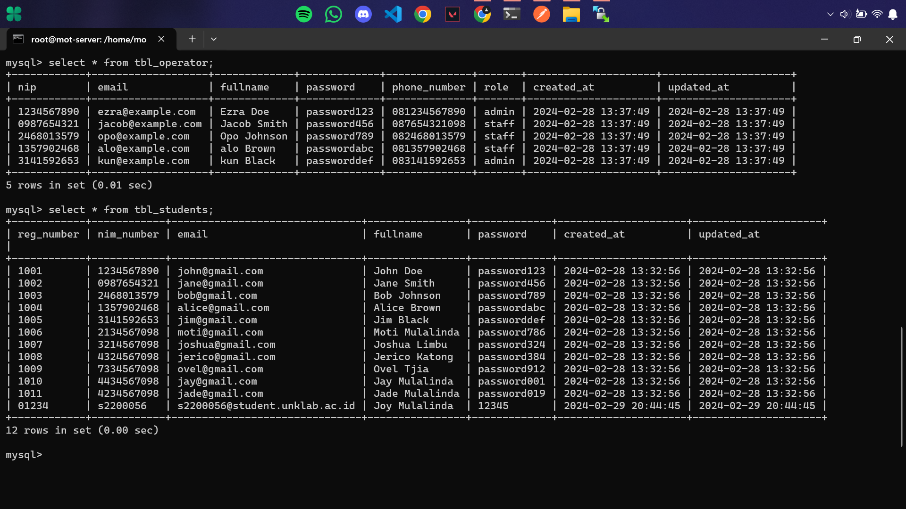

* **LOGIN FORM**

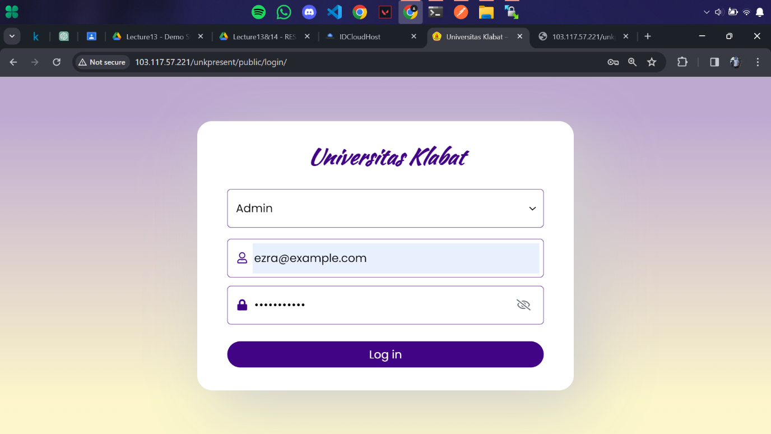

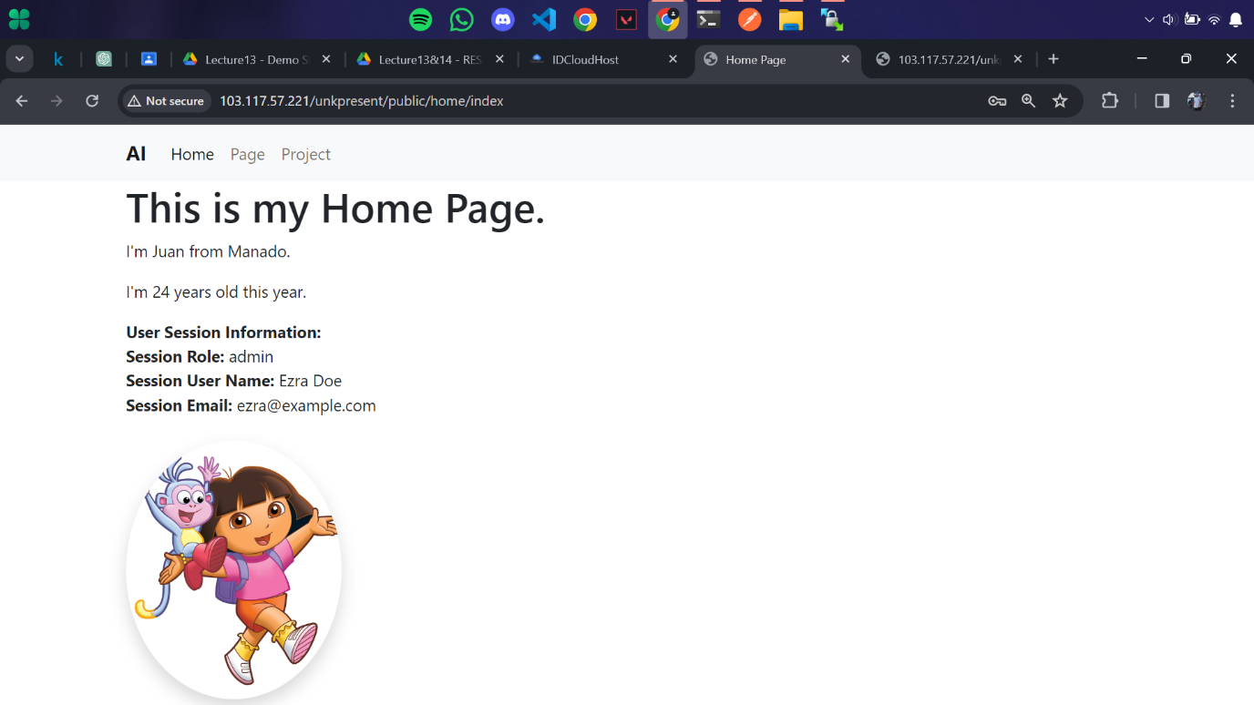

* **API POSTMAN (menggunakan metode GET)**

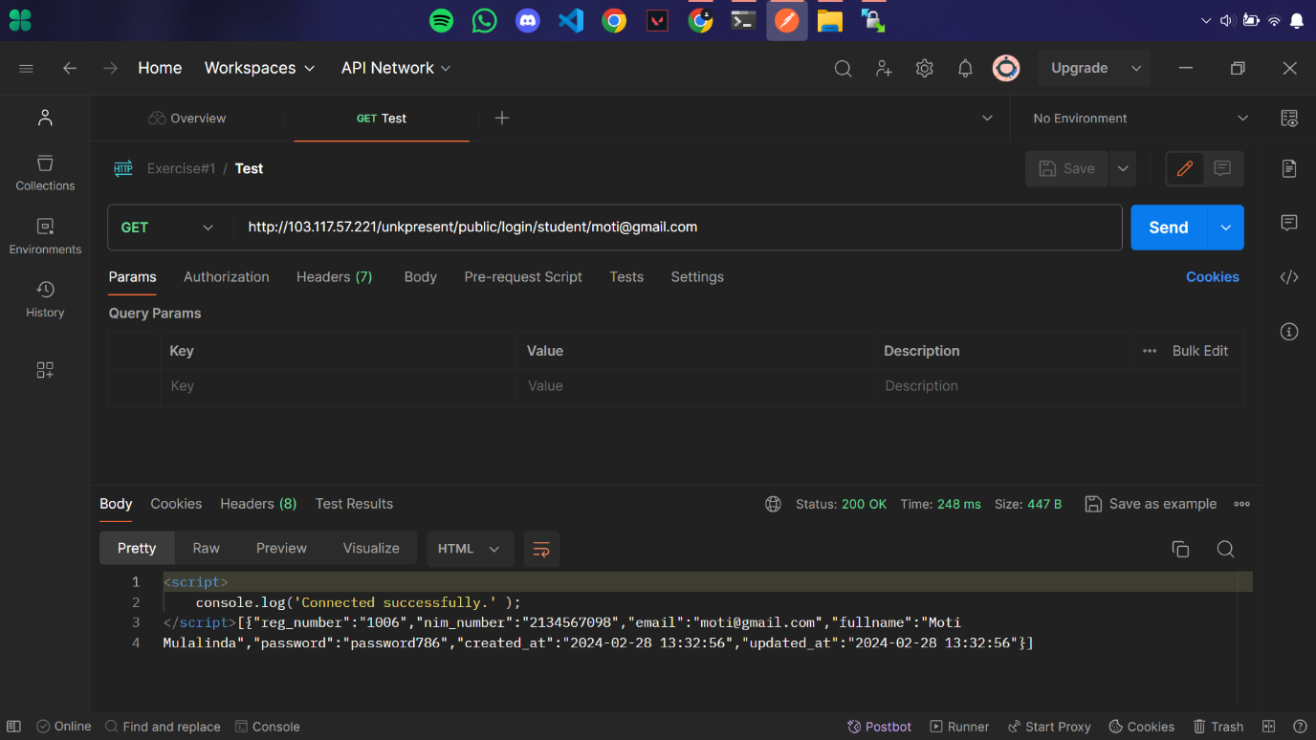

* **READ DATA FROM API**

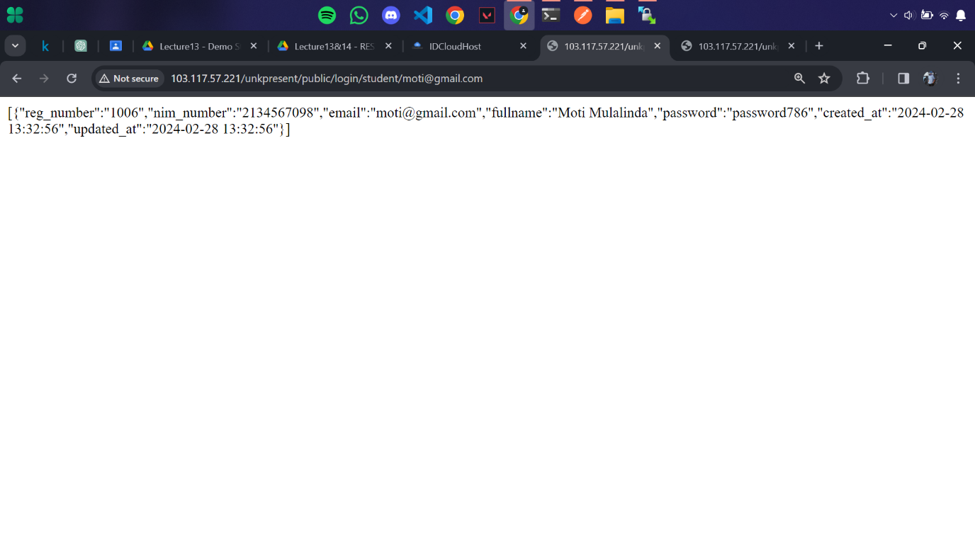

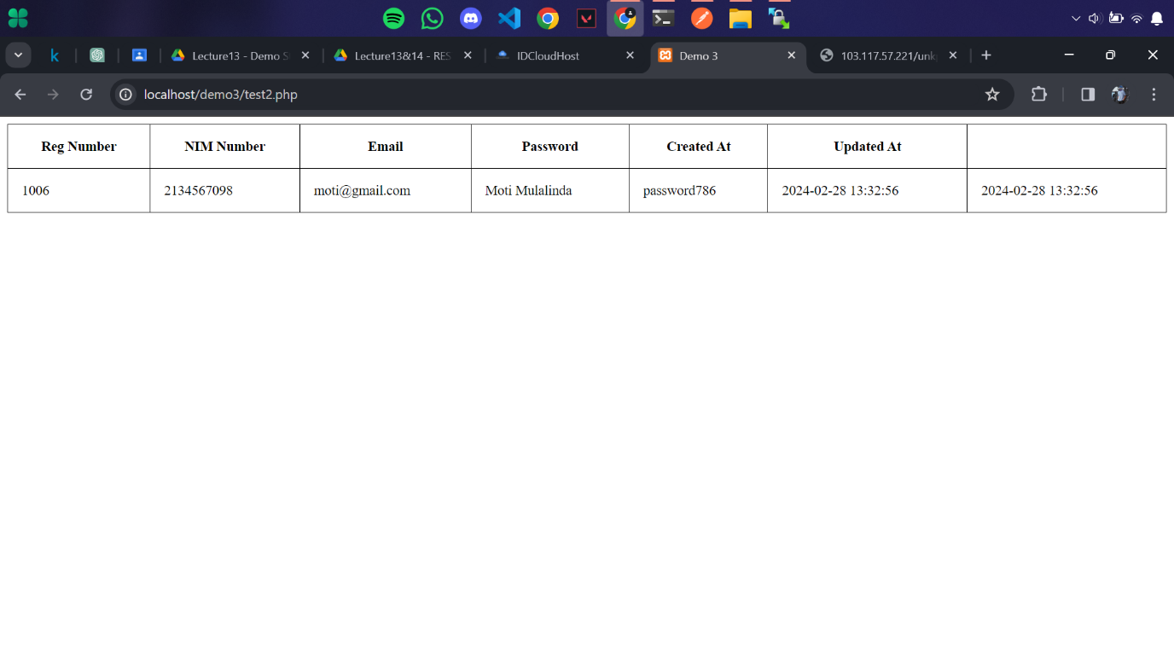

* **INSERT/PUSH DATA TO DATABASE**



